UNITED STATES

SECURITIES AND EXCHANGE COMMISSION
Washington, D.C. 20549

FORM 8-K

CURRENT REPORT

Pursuant to Section 13 OR 15(d) of The Securities Exchange Act of 1934

Date of Report (Date of earliest event reported): November 6, 2024

COLLEGIUM PHARMACEUTICAL, INC.

(Exact Name of Registrant as Specified in its Charter)

Virginia | 001-37372 | 03-0416362
(State or Other Jurisdiction | (Commission File Number) | (IRS Employer Identification
of Incorporation or Organization) |  | No.)
 | 100 Technology Center Drive
 | Suite 300
 | Stoughton, MA 02072
 | (Address of principal executive offices) (Zip Code)
 | Registrant’s telephone number, including area code: (781) 713-3699
 | Securities registered pursuant to Section 12(b) of the Act:
Title of each class | Trading Symbol(s) | Name of each exchange on which registered
Common stock, par value $0.001 per share | COLL | The NASDAQ Global Select Market

Check the appropriate box below if the Form 8-K filing is intended to simultaneously satisfy the filing obligation of the registrant under any of the following provisions (see General Instruction A.2. below):

- Written communications pursuant to Rule 425 under the Securities Act (17 CFR 230.425)

- Soliciting material pursuant to Rule 14a-12 under the Exchange Act (17 CFR 240.14a-12)

- Pre-commencement communications pursuant to Rule 14d-2(b) under the Exchange Act (17 CFR 240.14d-2(b))

- Pre-commencement communications pursuant to Rule 13e-4(c) under the Exchange Act (17 CFR 240.13e-4(c))

Indicate by check mark whether the registrant is an emerging growth company as defined in Rule 405 of the Securities Act of 1933 (§230.405 of this chapter) or Rule 12b-2 of the Securities Exchange Act of 1934 (§240.12b-2 of this chapter).

Emerging growth company ☐

If an emerging growth company, indicate by check mark if the registrant has elected not to use the extended transition period for complying with any new or revised financial accounting standards provided pursuant to Section 13(a) of the Exchange Act. ☐

Item 2.02 Results of Operations and Financial Condition.

On November 7, 2024, Collegium Pharmaceutical, Inc. (the “Company”) issued a press release announcing its financial results for the quarterly period ended September 30, 2024. The full text of the press release issued in connection with the announcement is attached hereto as Exhibit 99.1 and is being furnished, not filed, under Item 2.02 of this Current Report on Form 8-K.

Item 5.02 Departure of Directors or Certain Officers; Election of Directors; Appointment of Certain Officers; Compensatory Arrangements of Certain Officers.

Appointment of Chief Executive Officer

On November 6, 2024, the Board of Directors (the “Board”) of the Company appointed Vikram Karnani to serve as the Company’s President and Chief Executive Officer, effective November 12, 2024 (the “Effective Date”). Concurrently with his appointment as President and Chief Executive Officer and effective as of the Effective Date, Mr. Karnani will be appointed to serve as a member of the Board and the size of the Board will increase to eight directors. As of the Effective Date, Mr. Karnani will serve as the Company’s principal executive officer, succeeding Michael Heffernan, who will continue to serve as the Company’s Chairman of the Board.

Mr. Karnani, age 50, previously served as Executive Vice President and President, Global Commercial Operations and Medical Affairs at Amgen Inc. (“Amgen”), a global biotechnology company. Mr. Karnani joined Amgen in October 2023 through Amgen’s acquisition of Horizon Therapeutics plc (“Horizon”). Mr. Karnani joined Horizon in 2014, holding numerous leadership positions including Executive Vice President and President, International, from August 2020 until October 2023; Executive Vice President and Chief Commercial Officer from March 2018 to August 2020; Senior Vice President, Rheumatology Business Unit from February 2017 to March 2018; and General Manager, Specialty Business Unit from July 2014 until February 2017. Prior to joining Horizon, Mr. Karnani was with Fresenius Kabi AG (“Fresenius Kabi”), a global health care company, where he served as Vice President of the therapeutics and cell therapy business from October 2011 to July 2014. Mr. Karnani has a master’s degree from the Kellogg School of Management at Northwestern University, a master’s degree in electrical engineering from Case Western Reserve University and a bachelor of science degree in electrical engineering from University of Bombay, India.

In connection with Mr. Karnani’s appointment as the Company’s President and Chief Executive Officer, the Company and Mr. Karnani entered into an employment agreement on November 6, 2024 (the “Agreement”). Pursuant to the Agreement, which is effective as of the Effective Date, Mr. Karnani is eligible for (i) an annual base salary paid at the rate of $875,000 per year, (ii) an annual performance-based target bonus of 75% of his annual base salary, pro-rated for 2024, (iii) a one-time signing bonus of $500,000, and (iv) equity awards with an aggregate value of $10 million comprised of 25% stock options (the “Option”), 37.5% restricted stock units (the “RSUs”) and 37.5% performance share units (the “PSUs”). The Options, RSUs and PSUs will be granted to Mr. Karnani under the Company’s Amended and Restated 2014 Stock Incentive Plan (the “Plan”). Mr. Karnani will not be eligible for annual equity grants made to executives in early 2025, but shall be eligible for annual equity award grants in each year thereafter during his employment.

The Option will vest 25% on the first anniversary of the date that Mr. Karnani’s employment with the Company commences, with the remaining 75% vesting in quarterly installments over the next three years beginning on the first quarter following the first anniversary of the Option vesting commencement date, subject to Mr. Karnani’s continued employment with the Company and subject to the terms of the Plan. The Option will have an exercise price equal to the fair market value of the Company’s Common Stock on the grant date. The RSUs will vest 25% on the first anniversary of the date that Mr. Karnani’s employment with the Company commences, with the remaining 75% vesting in annual installments over the next three years beginning one year after the first anniversary of the RSU vesting commencement date, subject to Mr. Karnani’s continued service with the Company and subject to the terms of the Plan. Subject to Mr. Karnani’s continuous service through the applicable vesting dates and subject to the terms of the Plan, the PSUs will have a three-year performance period commencing January 1, 2025 and will vest based upon the Compensation Committee’s determination of the satisfaction of relative total shareholder return performance criteria to be set by the Board.

Upon a termination of Mr. Karnani’s employment without “cause” (as defined in the Agreement) by the Company or resignation for “good reason” (as defined in the Agreement), subject to, among other terms, Mr. Karnani’s execution of the “release” (as defined in the Agreement), Mr. Karnani is entitled to receive (i) payment of any annual bonus otherwise payable (but for the cessation of Mr. Karnani’s employment) with respect to a year ended prior to the cessation of employment; (ii) continuation of his base salary for eighteen (18) months; (iii) waiver of the applicable premium otherwise payable for COBRA continuation coverage for Mr. Karani for eighteen (18) months, (iv) payment equal to
- Mr. Karnani’s target bonus multiplied by (b) 1.5, paid in eighteen (18) substantially equal installments over an eighteen-month period and in accordance with the Company’s standard payroll practices; (v) accelerated vesting of any unvested equity awards that are solely subject to time-based vesting criteria equal to what would have vested had Mr. Karnani remained employed for eighteen (18) additional months; and (vi) accelerated vesting of any unvested equity awards that are subject to performance-based vesting criteria equal to what would have vested in connection with any annual or cumulative performance vesting period that ends during the eighteen (18) month period immediately following such termination of Mr. Karnani’s employment, such determination to be made by the Compensation Committee in its reasonable discretion.

Upon a termination of Mr. Karani’s employment without cause or for good reason within the one (1) month period prior to or the twelve (12) month period immediately following a “change in control” (as defined in the Agreement), subject to, among other terms, Mr. Karani’s execution of the release, then (i) all of Mr. Karnani’s unvested equity awards that are subject only to time-based vesting will become immediately and automatically fully vested and exercisable (as applicable); (ii) in lieu of continuation of Mr. Karnani’s salary for eighteen (18) months, Mr. Karnani shall receive two (2) times his base salary, paid in a lump sum; (iii) in lieu of any other bonus payment, Mr. Karnani shall receive two (2) times his target bonus payable in a lump sum; and (iv) Mr. Karani will be entitled to waiver of the applicable premium otherwise payable for COBRA continuation coverage for Mr. Karani for twenty-four (24) months in lieu of eighteen (18) months (provided that if such COBRA continuation period expires after eighteen (18) months under applicable law, the Company will instead pay to Mr. Karani a taxable lump sum payment equal to six (6) months of the monthly COBRA premium then in effect). Any unvested equity awards that are subject to performance-based vesting shall become vested in accordance with the Plan and the applicable award agreement.

The foregoing description of the Agreement does not purport to be complete and is qualified in its entirety by reference to the Agreement, which will be filed as an exhibit to the Company’s Annual Report on Form 10-K for the year ended December 31, 2024.

There are no arrangements or understandings between Mr. Karnani and any other persons pursuant to which Mr. Karnani was appointed as President and Chief Executive Officer of the Company. In addition, there are no family relationships between Mr. Karnani and any director or executive officer of the Company, and there are no transactions involving Mr. Karnani requiring disclosure under Item 404(a) of Regulation S-K.

On November 7, 2024, the Company issued a press release announcing the appointment of Mr. Karnani to Chief Executive Officer. The full text of this press release is attached hereto as Exhibit 99.2.

Item 7.01 Regulation FD Disclosure.

On November 7, 2024, the Company released an earnings presentation and issued a press release announcing the appointment of Mr. Karnani to Chief Executive Officer. The presentation is attached hereto as Exhibit 99.2 and the press release is attached hereto as Exhibit 99.3, and each is being furnished, not filed, under Item 7.01 of this Current Report on Form 8-K.

Item 9.01 Financial Statements and Exhibits.

(d) Exhibits
Exhibit
No. |  |  | Description
99.1 |  |  | Press Release, dated November 7, 2024
99.2 |  |  | Earnings Presentation, dated November 7, 2024
99.3 |  |  | Press Release, dated November 7, 2024
104 |  |  | Cover Page Interactive Data File (embedded within the Inline XBRL document)

SIGNATURES

Pursuant to the requirements of the Securities Exchange Act of 1934, the registrant has duly caused this report to be signed on its behalf by the undersigned hereunto duly authorized.

Dated: November 7, 2024 Collegium Pharmaceutical, Inc.

By: | /s/ Colleen Tupper
 | Name: Colleen Tupper
 | Title: Executive Vice President and Chief Financial Officer

Exhibit 99.1


Collegium Reports Record Third Quarter 2024 Financial Results

– Generated Record Q3’24 Net Revenue of $159.3 Million, Up 17% Year-over-Year, Driven by Record Belbuca® Revenue of $53.2 Million and Record Xtampza® ER Revenue of $49.5 Million –

– Achieved Q3’24 GAAP Net Income of $9.3 Million –

– Delivered Record Q3’24 Adjusted EBITDA of $105.1 Million, Up 18% Year-over-Year –

– Closed Acquisition of Ironshore Therapeutics, Establishing Presence in Neurology (ADHD) –

– Appointed Vikram Karnani as Chief Executive Officer of Collegium –

– Conference Call Scheduled for Today at 4:30 p.m. ET –

STOUGHTON, Mass., November 7, 2024 -- Collegium Pharmaceutical, Inc. (Nasdaq: COLL), a leading, diversified specialty pharmaceutical company committed to improving the lives of people living with serious medical conditions, today reported its financial results for the quarter ended September 30, 2024, and provided a corporate update.

“Collegium’s strong operational execution led to record quarterly pain portfolio revenue, with 11% year-over-year growth, and enabled our recent acquisition of Ironshore, which expands our presence into neurology with the addition of Jornay PM®,” said Michael Heffernan, Chairman and Interim President and Chief Executive Officer of Collegium. “We are committed to the seamless integration of Ironshore and maximizing the value of Jornay PM, which is poised to be our lead growth driver and our first step toward building another therapeutic area of focus. With the appointment of Vikram Karnani as our new CEO, Collegium is well positioned for its next phase of growth.”

“Collegium continues to deliver on our commitment to top- and bottom- line growth, and we are on track to achieve our financial guidance for the year. The performance of our pain portfolio this quarter, including record Belbuca and Xtampza ER revenue, coupled with the immediate accretion from Jornay PM, which is expected to deliver pro forma net revenue in excess of $100 million in 2024, underscores the financial strength of the company,” said Colleen Tupper, Chief Financial Officer of Collegium. “Looking to 2025, we expect to generate record revenue driven by growth in our pain portfolio and the addition of Jornay PM.”

Business Highlights

- In September 2024, announced the closing of the acquisition of Ironshore Therapeutics Inc. (Ironshore), which included commercial product Jornay PM for the treatment of ADHD, establishing a presence in neurology. Jornay PM is poised to become Collegium’s lead growth driver.

- Jornay PM prescriptions grew 31.2% year-over-year in the nine months ended September 30, 2024.

- Grew Belbuca total prescriptions 3.5% year-over-year and 2.6% quarter-over-quarter in the quarter ended September 30, 2024. Belbuca net revenue was a record $53.2 million, up 17% year-over-year.

- Xtampza ER net revenue was a record $49.5 million, up 24% year-over-year.

- Achieved a new payor win for Belbuca and Xtampza ER in a large integrated health system that represents approximately eight million commercial lives and two million Medicare Part D lives.

- Presented eight posters at PAINWeek Conference 2024 highlighting clinical and population health impact of Collegium’s differentiated pain portfolio.

- Presented a poster on Jornay PM at American Academy of Child and Adolescent Psychiatry (AACAP) 2024 Annual Meeting and Canadian ADHD Resource Alliance (CADDRA) 2024 ADHD Conference and had commercial and medical presence at 2024 Psych Congress.

- In November 2024, announced that Vikram Karnani has been appointed President and Chief Executive Officer of Collegium and will join its Board of Directors effective November 12, 2024.

Financial Guidance for 2024

The Company reaffirms its full-year 2024 guidance as updated in September 2024 following the close of the Ironshore acquisition for Product Revenues, Net, Adjusted Operating Expenses and Adjusted EBITDA for its current business.

Product Revenues, Net | $620.0 to $635.0 million
Adjusted Operating Expenses | $150.0 to $155.0 million
(Excluding Stock-Based Compensation) | $150.0 to $155.0 million
Adjusted EBITDA | $395.0 to $405.0 million
(Excluding Stock-Based Compensation) | $395.0 to $405.0 million

Financial Results for Quarter Ended September 30, 2024

- Product revenues, net were $159.3 million for the quarter ended September 30, 2024 (the 2024 Quarter), compared to $136.7 million for the quarter ended September 30, 2023 (the 2023 Quarter), representing a 17% increase year-over-year.

- GAAP operating expenses were $62.0 million for the 2024 Quarter, compared to $35.3 million for the 2023 Quarter, representing a 76% increase year-over-year. Adjusted operating expenses, which exclude stock-based compensation and acquisition related expenses, were $34.8 million for the 2024 Quarter, compared to $28.3 million for the 2023 Quarter, representing a 23% increase year-over-year.

- GAAP net income for the 2024 Quarter was $9.3 million, with $0.29 GAAP earnings per share (basic) and $0.27 GAAP earnings per share (diluted), compared to GAAP net income for the 2023 Quarter of $20.6 million, with $0.61 GAAP earnings per share (basic) and $0.53 GAAP earnings per share (diluted). Non-GAAP adjusted net income for the 2024 Quarter was $63.5 million, with $1.61 adjusted earnings per share, compared to non-GAAP adjusted net income for the 2023 Quarter of $55.0 million, with $1.34 adjusted earnings per share.

- Adjusted EBITDA for the 2024 Quarter was $105.1 million, compared to $89.4 million for the 2023 Quarter, representing an 18% increase year-over-year.

- The Company exited the 2024 Quarter with cash, cash equivalents and marketable securities of $120.0 million, down from $310.5 million as of December 31, 2023.

Conference Call Information

The Company will host a conference call and live audio webcast on Thursday, November 7, 2024, at 4:30 p.m. ET. To access the conference call, please dial (877) 407-8037 (U.S.) or (201) 689-8037 (International) and reference the “Collegium Pharmaceutical Q3 2024 Earnings Call.” An audio webcast will be accessible from the Investors section of the Company’s website: www.collegiumpharma.com. The webcast will be available for replay on the Company’s website approximately two hours after the event.

About Collegium Pharmaceutical, Inc.

Collegium is a leading, diversified specialty pharmaceutical company committed to improving the lives of people living with serious medical conditions. Collegium’s headquarters are located in Stoughton, Massachusetts. For more information, please visit the Company’s website at www.collegiumpharma.com.

Non-GAAP Financial Measures

To supplement our financial results presented on a GAAP basis, we have included information about certain non-GAAP financial measures. We believe the presentation of these non-GAAP financial measures, when viewed with our results under GAAP and the accompanying reconciliations, provide analysts, investors, lenders, and other third parties with insights into how we evaluate normal operational activities, including our ability to generate cash from operations, on a comparable year-over-year basis and manage our budgeting and forecasting. In addition, certain non-GAAP financial measures, primarily adjusted EBITDA, are used to measure performance when determining components of annual compensation for substantially all non-sales force employees, including senior management.

We may discuss the following financial measures that are not calculated in accordance with GAAP in our quarterly and annual reports, earnings press releases, and conference calls.

Adjusted EBITDA

Adjusted EBITDA is a non-GAAP financial measure that represents GAAP net income or loss adjusted to exclude interest expense, interest income, the benefit from or provision for income taxes, depreciation, amortization, stock-based compensation, and other adjustments to reflect changes that occur in our business but do not represent ongoing operations. Adjusted EBITDA, as used by us, may be calculated differently from, and therefore may not be comparable to, similarly titled measures used by other companies.

There are several limitations related to the use of adjusted EBITDA rather than net income or loss, which is the nearest GAAP equivalent, such as:

- adjusted EBITDA excludes depreciation and amortization, and, although these are non-cash expenses, the assets being depreciated or amortized may have to be replaced in the future, the cash requirements for which are not reflected in adjusted EBITDA;

- adjusted EBITDA does not reflect changes in, or cash requirements for, working capital needs;

- adjusted EBITDA does not reflect the benefit from or provision for income taxes or the cash requirements to pay taxes;

- adjusted EBITDA does not reflect historical cash expenditures or future requirements for capital expenditures or contractual commitments;

- we exclude stock-based compensation expense from adjusted EBITDA although: (i) it has been, and will continue to be for the foreseeable future, a significant recurring expense for our business and an important part of our compensation strategy; and (ii) if we did not pay out a portion of our compensation in the form of stock-based compensation, the cash salary expense included in operating expenses would be higher, which would affect our cash position;

- we exclude impairment expenses from adjusted EBITDA and, although these are non-cash expenses, the asset(s) being impaired may have to be replaced in the future, the cash requirements for which are not reflected in adjusted

EBITDA;

- we exclude restructuring expenses from adjusted EBITDA. Restructuring expenses primarily include employee severance and contract termination costs that are not related to acquisitions. The amount and/or frequency of these restructuring expenses are not part of our underlying business;

- we exclude litigation settlements from adjusted EBITDA, as well as any applicable income items or credit adjustments due to subsequent changes in estimates. This does not include our legal fees to defend claims, which are expensed as incurred;

- we exclude acquisition related expenses as the amount and/or frequency of these expenses are not part of our underlying business. Acquisition related expenses include transaction costs, which primarily consisted of financial advisory, banking, legal, and regulatory fees, and other consulting fees, incurred to complete the acquisition, employee-related expenses (severance cost and benefits) for terminated employees after the acquisition, and miscellaneous other acquisition related expenses incurred;

- we exclude recognition of the step-up basis in inventory from acquisitions (i.e., the adjustment to record inventory from historic cost to fair value at acquisition) as the adjustment does not reflect the ongoing expense associated with sale of our products as part of our underlying business;

- we exclude losses on extinguishments of debt as these expenses are episodic in nature and do not directly correlate to the cost of operating our business on an ongoing basis; and

- we exclude other expenses, from time to time, that are episodic in nature and do not directly correlate to the cost of operating our business on an ongoing basis.

Adjusted Operating Expenses

Adjusted operating expenses is a non-GAAP financial measure that represents GAAP operating expenses adjusted to exclude stock-based compensation expense, and other adjustments to reflect changes that occur in our business but do not represent ongoing operations.

Adjusted Net Income and Adjusted Earnings Per Share

Adjusted net income is a non-GAAP financial measure that represents GAAP net income or loss adjusted to exclude significant income and expense items that are non-cash or not indicative of ongoing operations, including consideration of the tax effect of the adjustments. Adjusted earnings per share is a non-GAAP financial measure that represents adjusted net income per share. Adjusted weighted-average shares - diluted is calculated in accordance with the treasury stock, if-converted, or contingently issuable accounting methods, depending on the nature of the security.

Reconciliations of adjusted EBITDA, adjusted operating expenses, adjusted net income, and adjusted earnings per share to the most directly comparable GAAP financial measures are included in this press release.

The Company has not provided a reconciliation of its full-year 2024 guidance for adjusted EBITDA or adjusted operating expenses to the most directly comparable forward-looking GAAP measures, in reliance on the unreasonable efforts exception provided under Item 10(e)(1)(i)(B) of Regulation S-K, because the Company is unable to predict, without unreasonable efforts, the timing and amount of items that would be included in such a reconciliation, including, but not limited to, stock-based compensation expense, acquisition related expense and litigation settlements. These items are uncertain and depend on various factors that are outside of the Company’s control or cannot be reasonably predicted. While the Company is unable to address the probable significance of these items, they could have a material impact on GAAP net income and operating expenses for the guidance period. A reconciliation of adjusted EBITDA or adjusted operating expenses would imply a degree of precision and certainty as to these future items that does not exist and could be confusing to investors.

Forward-Looking Statements

This press release contains forward-looking statements within the meaning of The Private Securities Litigation Reform Act of 1995. We may, in some cases, use terms such as "predicts," "forecasts," "believes," "potential," "proposed," "continue," "estimates," "anticipates," "expects," "plans," "intends," "may," "could," "might," "should" or other words that convey uncertainty of future events or outcomes to identify these forward-looking statements. Examples of forward-looking statements contained in this press release include, among others, statements related to our full-year 2024 financial guidance, including projected product revenue, adjusted operating expenses and adjusted EBITDA, current and future market opportunities for our products and our assumptions related thereto, expectations (financial or otherwise) and intentions, and other statements that are not historical facts. Such statements are subject to numerous important factors, risks and uncertainties that may cause actual events or results, performance, or achievements to differ materially from the company's current expectations, including risks relating to, among others: unknown liabilities; risks related to future opportunities and plans for our products, including uncertainty of the expected financial performance of such products; our ability to commercialize and grow sales of our products; our ability to successfully integrate the operations of Ironshore into our organization, and realize the anticipated benefits associated with the acquisition; our ability to manage our relationships with licensors; the success of competing products that are or become available; our ability to maintain regulatory approval of our products, and any related restrictions, limitations, and/or warnings in the label of our products; the size of the markets for our products, and our ability to service those markets; our ability to obtain reimbursement and third-party payor contracts for our products; the rate and degree of market acceptance of our products; the costs of commercialization activities, including marketing, sales and distribution; changing market conditions for our products; the outcome of any patent infringement or other litigation that may be brought by or against us; the outcome of any governmental investigation related to our business; our ability to secure adequate supplies of active pharmaceutical ingredient for each of our products and manufacture adequate supplies of commercially saleable inventory; our ability to obtain funding for our operations and business development; regulatory developments in the U.S.; our expectations regarding our ability to obtain and maintain sufficient intellectual property protection for our products; our ability to comply with stringent U.S. and foreign government regulation in the manufacture of pharmaceutical products, including U.S. Drug Enforcement Agency, or DEA, compliance; our customer concentration; and the accuracy of our estimates regarding expenses, revenue, capital requirements and need for additional financing. These and other risks are described under the heading "Risk Factors" in our Annual Reports on Form 10-K and Quarterly Reports on Form 10-Q and other filings with the SEC. Any forward-looking statements that we make in this press release speak only as of the date of this press release. We assume no obligation to update our forward-looking statements whether as a result of new information, future events or otherwise, after the date of this press release.

Investor Contact:

Danielle Jesse

Director, Investor Relations

ir@collegiumpharma.com

Media Contact:

Marissa Samuels

Vice President, Corporate Communications

communications@collegiumpharma.com

Cash and cash equivalents

Marketable securities

Accounts receivable, net

Inventory

Prepaid expenses and other current assets

Property and equipment, net

Operating lease assets

Intangible assets, net

Restricted cash

Deferred tax assets

Other noncurrent assets

Goodwill

Total assets

Collegium Pharmaceutical, Inc.

Unaudited Selected Consolidated Balance Sheet Information

(in thousands)

 | September 30, |  |  | December 31,
 | 2024 |  |  | 2023
$ | 38,960 |  | $ | 238,947
 | 80,997 |  |  | 71,601
 | 228,456 |  |  | 179,525
 | 38,032 |  |  | 32,332
 | 32,365 |  |  | 15,195
 | 14,614 |  |  | 15,983
 | 6,169 |  |  | 6,029
 | 946,875 |  |  | 421,708
 | 26,047 |  |  | 1,047
 | 72,509 |  |  | 26,259
 | 4,171 |  |  | 825
 | 145,959 |  |  | 133,857
$ | 1,635,154 |  | $ | 1,143,308

Accounts payable and accrued liabilities |  | 50,742 |  |  | 46,263
Accrued rebates, returns and discounts |  | 313,874 |  |  | 227,331
Business combination consideration payable |  | 28,956 |  |  | —
Term notes payable |  | 630,299 |  |  | 405,046
Convertible senior notes |  | 236,911 |  |  | 262,125
Operating lease liabilities |  | 7,185 |  |  | 7,112
Deferred royalty obligation |  | 118,812 |  |  | —
Deferred revenue |  | 10,000 |  |  | —
Contingent consideration |  | 4,096 |  |  | —
Shareholders’ equity |  | 234,279 |  |  | 195,431
Total liabilities and shareholders’ equity | $ | 1,635,154 |  | $ | 1,143,308

 | Collegium Pharmaceutical, Inc.
 | Unaudited Condensed Statements of Operations
 | (in thousands, except share and per share amounts)
 |  |  | Three Months Ended September 30, |  |  |  |  |  | Nine Months Ended September 30,
 |  |  | 2024 |  |  | 2023 |  |  | 2024 |  |  | 2023
Product revenues, net |  | $ | 159,301 |  | $ | 136,709 |  | $ | 449,500 |  | $ | 417,022
Cost of product revenues
Cost of product revenues (excluding intangible asset amortization) |  |  | 21,706 |  |  | 20,081 |  |  | 60,611 |  |  | 74,237
Intangible asset amortization |  |  | 40,801 |  |  | 36,317 |  |  | 109,833 |  |  | 111,246
Total cost of product revenues |  |  | 62,507 |  |  | 56,398 |  |  | 170,444 |  |  | 185,483
Gross profit |  |  | 96,794 |  |  | 80,311 |  |  | 279,056 |  |  | 231,539
Operating expenses
Selling, general and administrative |  |  | 61,955 |  |  | 35,298 |  |  | 147,272 |  |  | 126,266
Total operating expenses |  |  | 61,955 |  |  | 35,298 |  |  | 147,272 |  |  | 126,266
Income from operations |  |  | 34,839 |  |  | 45,013 |  |  | 131,784 |  |  | 105,273
Interest expense |  |  | (18,394) |  |  | (20,768) |  |  | (51,320) |  |  | (64,058)
Interest income |  |  | 3,280 |  |  | 4,538 |  |  | 12,164 |  |  | 11,312
Loss on extinguishment of debt |  |  | (4,145) |  |  | — |  |  | (11,329) |  |  | (23,504)
Income before income taxes |  |  | 15,580 |  |  | 28,783 |  |  | 81,299 |  |  | 29,023
Provision for income taxes |  |  | 6,245 |  |  | 8,149 |  |  | 24,645 |  |  | 12,808
Net income |  | $ | 9,335 |  | $ | 20,634 |  | $ | 56,654 |  | $ | 16,215
Earnings per share — basic | $ |  | 0.29 |  | $ | 0.61 |  | $ | 1.75 |  | $ | 0.47
Weighted-average shares — basic |  |  | 32,259,468 |  |  | 33,744,209 |  |  | 32,339,401 |  |  | 34,226,488
Earnings per share — diluted | $ |  | 0.27 |  | $ | 0.53 |  | $ | 1.51 |  | $ | 0.46
Weighted-average shares — diluted |  |  | 40,163,266 |  |  | 42,058,821 |  |  | 40,400,483 |  |  | 35,149,154

 | Collegium Pharmaceutical, Inc.
 | Reconciliation of GAAP Net Income (Loss) to Adjusted EBITDA
 | (in thousands)
 | (unaudited)
 |  |  | Three Months Ended September 30, |  |  |  |  |  | Nine Months Ended September 30,
 |  |  | 2024 |  |  | 2023 |  |  | 2024 |  |  | 2023
GAAP net income |  | $ | 9,335 |  | $ | 20,634 |  | $ | 56,654 |  | $ | 16,215
Adjustments:
Interest expense |  |  | 18,394 |  |  | 20,768 |  |  | 51,320 |  |  | 64,058
Interest income |  |  | (3,280) |  |  | (4,538) |  |  | (12,164) |  |  | (11,312)
Loss on extinguishment of debt |  |  | 4,145 |  |  | — |  |  | 11,329 |  |  | 23,504
Provision for income taxes |  |  | 6,245 |  |  | 8,149 |  |  | 24,645 |  |  | 12,808
Depreciation |  |  | 946 |  |  | 835 |  |  | 2,815 |  |  | 2,547
Amortization |  |  | 40,801 |  |  | 36,317 |  |  | 109,833 |  |  | 111,246
Stock-based compensation |  |  | 7,317 |  |  | 7,027 |  |  | 24,804 |  |  | 20,134
Litigation settlements |  |  | — |  |  | — |  |  | — |  |  | 8,500
Recognition of step-up basis in inventory |  |  | 1,301 |  |  | 198 |  |  | 1,301 |  |  | 15,116
CEO transition expense |  |  | — |  |  | — |  |  | 3,051 |  |  | —
Acquisition related expenses |  |  | 19,886 |  |  | — |  |  | 19,886 |  |  | —
Total adjustments |  | $ | 95,755 |  | $ | 68,756 |  | $ | 236,820 |  | $ | 246,601
Adjusted EBITDA |  | $ | 105,090 |  | $ | 89,390 |  | $ | 293,474 |  | $ | 262,816

 | Collegium Pharmaceutical, Inc.
 | Reconciliation of GAAP Operating Expenses to Adjusted Operating Expenses
 | (in thousands)
 | (unaudited)
 |  | Three Months Ended September 30, |  |  |  |  |  |  | Nine Months Ended September 30,
 |  | 2024 |  |  | 2023 |  |  |  | 2024 |  |  | 2023
GAAP operating expenses |  | $ | 61,955 |  | $ | 35,298 |  | $ | 147,272 |  | $ | 126,266
Adjustments:
Stock-based compensation |  |  | 7,317 |  |  | 7,027 |  |  | 24,804 |  |  | 20,134
Litigation settlements |  |  | — |  |  | — |  |  | — |  |  | 8,500
CEO transition expense |  |  | — |  |  | — |  |  | 3,051 |  |  | —
Acquisition related expenses |  |  | 19,886 |  |  | — |  |  | 19,886 |  |  | —
Total adjustments |  | $ | 27,203 |  | $ | 7,027 |  | $ | 47,741 |  | $ | 28,634
Adjusted operating expenses |  | $ | 34,752 |  | $ | 28,271 |  | $ | 99,531 |  | $ | 97,632

 | Collegium Pharmaceutical, Inc.
 | Reconciliation of GAAP Net Income (Loss) to Adjusted Net Income and Adjusted Earnings Per Share
 | (in thousands, except share and per share amounts)
 | (unaudited)
 |  |  | Three Months Ended September 30, |  |  |  |  |  | Nine Months Ended September 30,
 |  |  | 2024 |  |  | 2023 |  |  | 2024 |  |  | 2023
GAAP net income |  | $ | 9,335 |  | $ | 20,634 |  | $ | 56,654 |  | $ | 16,215
Adjustments:
Non-cash interest expense |  |  | 1,681 |  |  | 2,124 |  |  | 5,065 |  |  | 6,672
Loss on extinguishment of debt |  |  | 4,145 |  |  | — |  |  | 11,329 |  |  | 23,504
Amortization |  |  | 40,801 |  |  | 36,317 |  |  | 109,833 |  |  | 111,246
Stock-based compensation |  |  | 7,317 |  |  | 7,027 |  |  | 24,804 |  |  | 20,134
Litigation settlements |  |  | — |  |  | — |  |  | — |  |  | 8,500
Recognition of step-up basis in inventory |  |  | 1,301 |  |  | 198 |  |  | 1,301 |  |  | 15,116
CEO transition expense |  |  | — |  |  | — |  |  | 3,051 |  |  | —
Acquisition related expenses |  |  | 19,886 |  |  | — |  |  | 19,886 |  |  | —
Income tax effect of above adjustments ⁽¹⁾ |  |  | (20,974) |  |  | (11,300) |  |  | (45,635) |  |  | (42,274)
Total adjustments |  | $ | 54,157 |  | $ | 34,366 |  | $ | 129,634 |  | $ | 142,898
Non-GAAP adjusted net income |  | $ | 63,492 |  | $ | 55,000 |  | $ | 186,288 |  | $ | 159,113
Adjusted weighted-average shares — diluted ⁽²⁾ |  |  | 40,163,266 |  |  | 42,058,820 |  |  | 40,400,483 |  |  | 41,679,546
Adjusted earnings per share ⁽²⁾
Adjusted earnings per share ⁽²⁾ | $ |  | 1.61 |  | $ | 1.34 |  | $ | 4.71 |  | $ | 3.91

- The income tax effect of the adjustments was calculated by applying our blended federal and state statutory rate to the items that have a tax effect. The blended federal and state statutory rate for the three months ended September 30, 2024 and 2023 were 28.1% and 25.6%, respectively; and the blended federal and state statutory rate for the nine months ended September 30, 2024 and 2023 were 27.1% and 25.6%, respectively. As such, the non-GAAP effective tax rates for the three months ended September 30, 2024 and 2023 were 27.9% and 24.7%, respectively; and the non-GAAP effective tax rates for the nine months ended September 30, 2024 and 2023 were 26.0% and 22.8%, respectively.
- Adjusted weighted-average shares - diluted were calculated using the “if-converted” method for our convertible notes in accordance with ASC 260, Earnings per Share. As such, adjusted weighted-average shares – diluted includes shares related to the assumed conversion of our convertible notes and the associated cash interest expense added-back to non-GAAP adjusted net income. For the three months ended September 30, 2024 and 2023, adjusted weighted-average shares – diluted includes 6,606,305 and 7,509,104 shares, respectively, attributable to our convertible notes. For the nine months ended September 30, 2024 and 2023, adjusted weighted-average shares – diluted includes 6,606,305 and 6,530,392 shares, respectively, attributable to our convertible notes. In addition, adjusted earnings per share includes other potentially dilutive securities to the extent that they are not antidilutive.

Exhibit 99.2


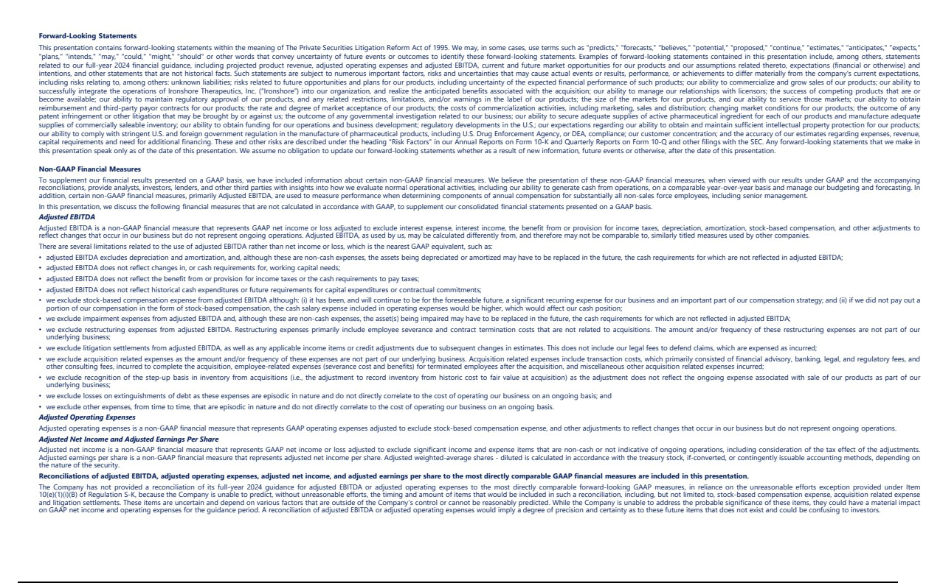

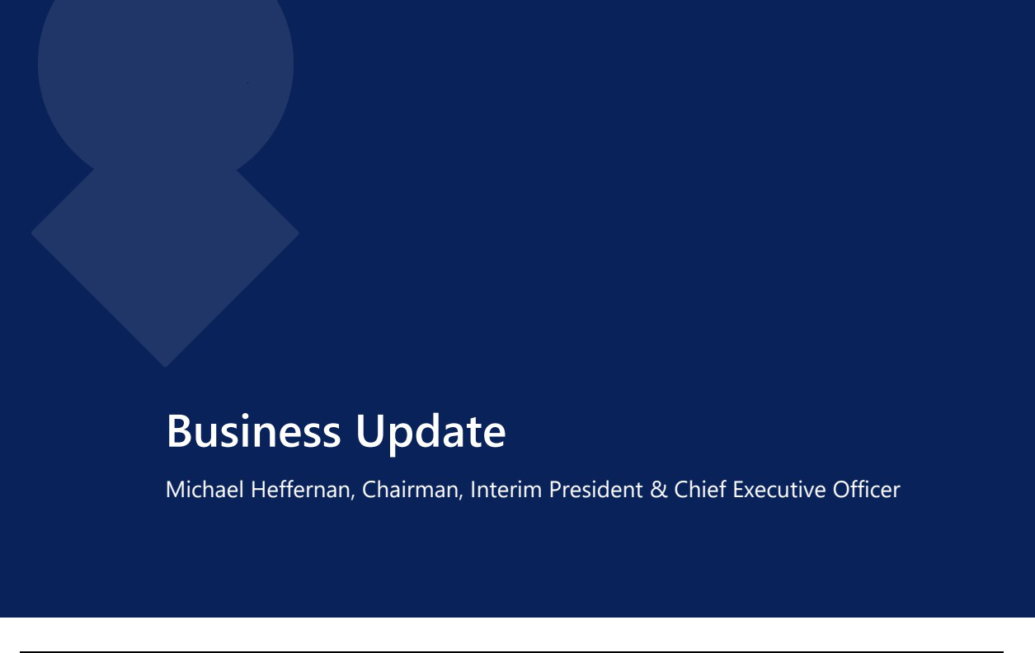

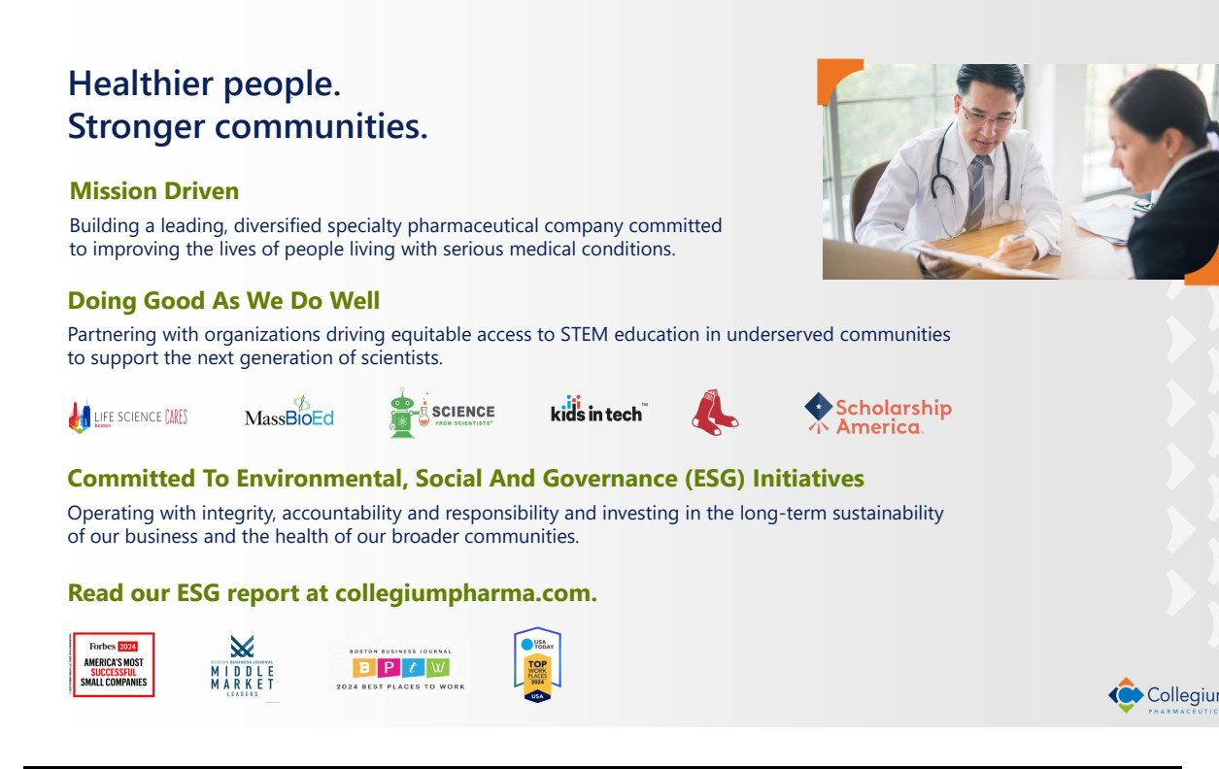

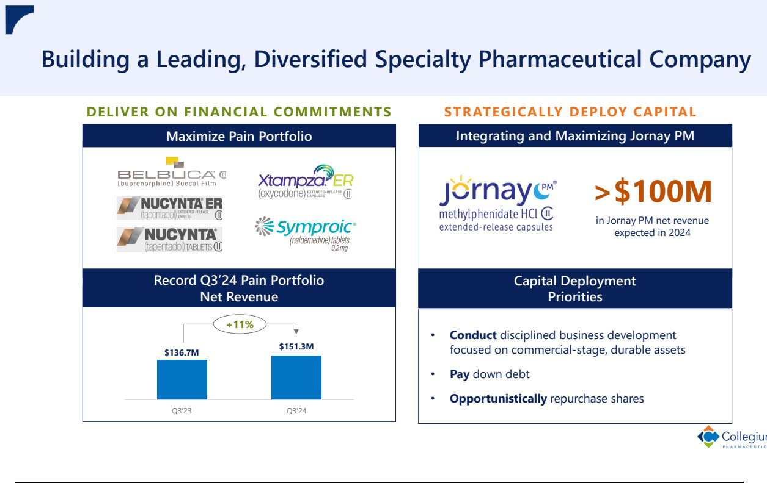

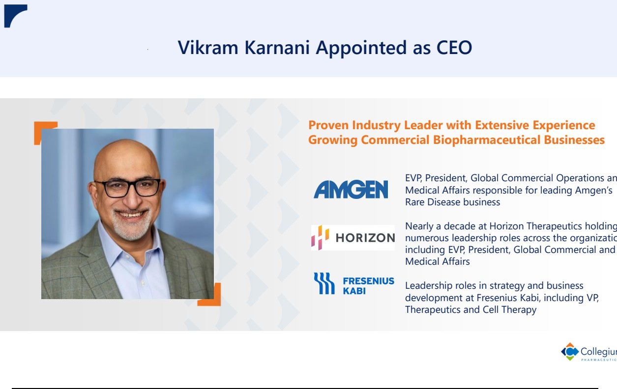

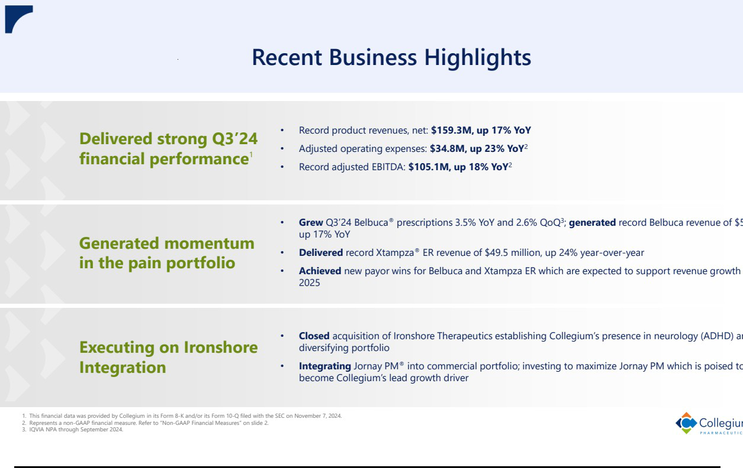



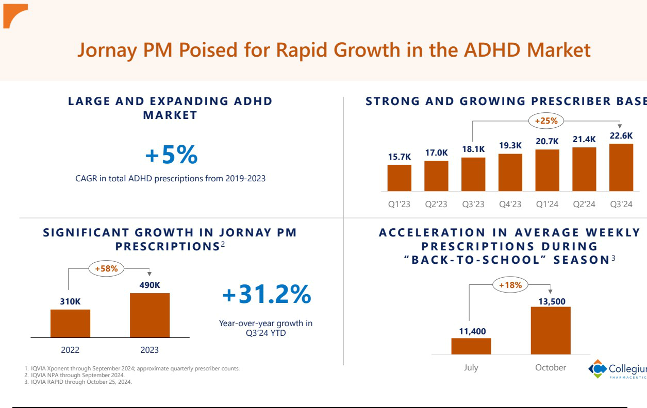

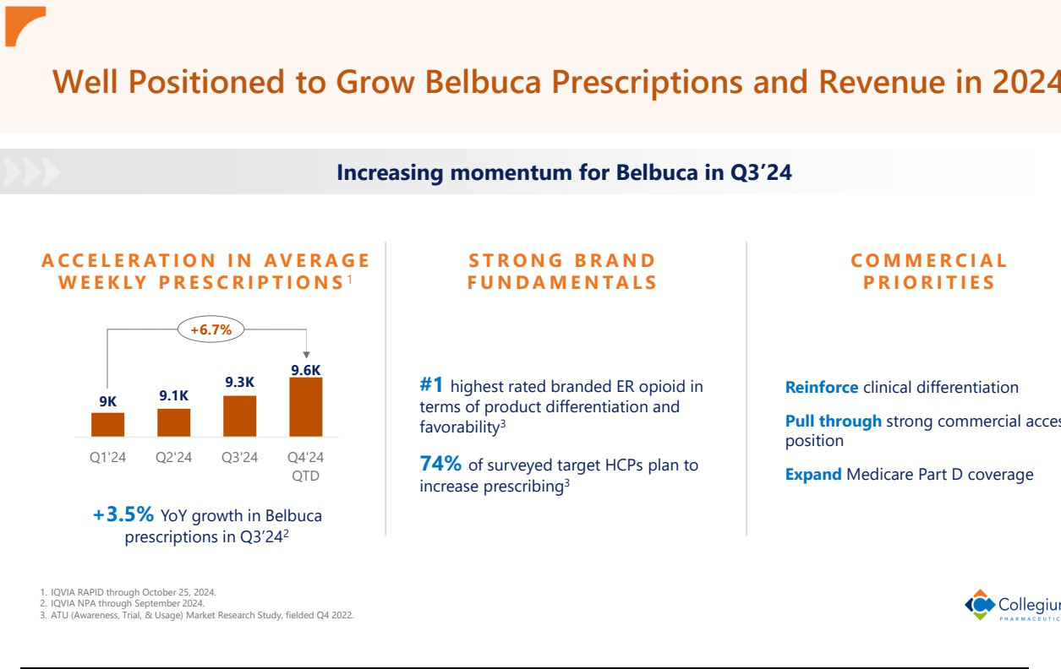

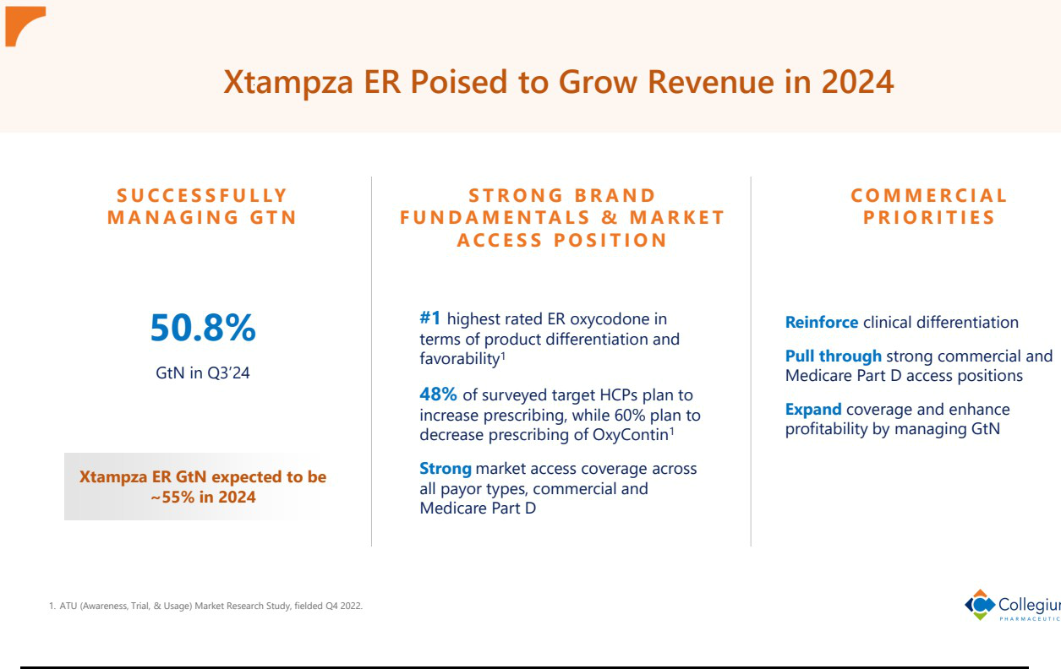

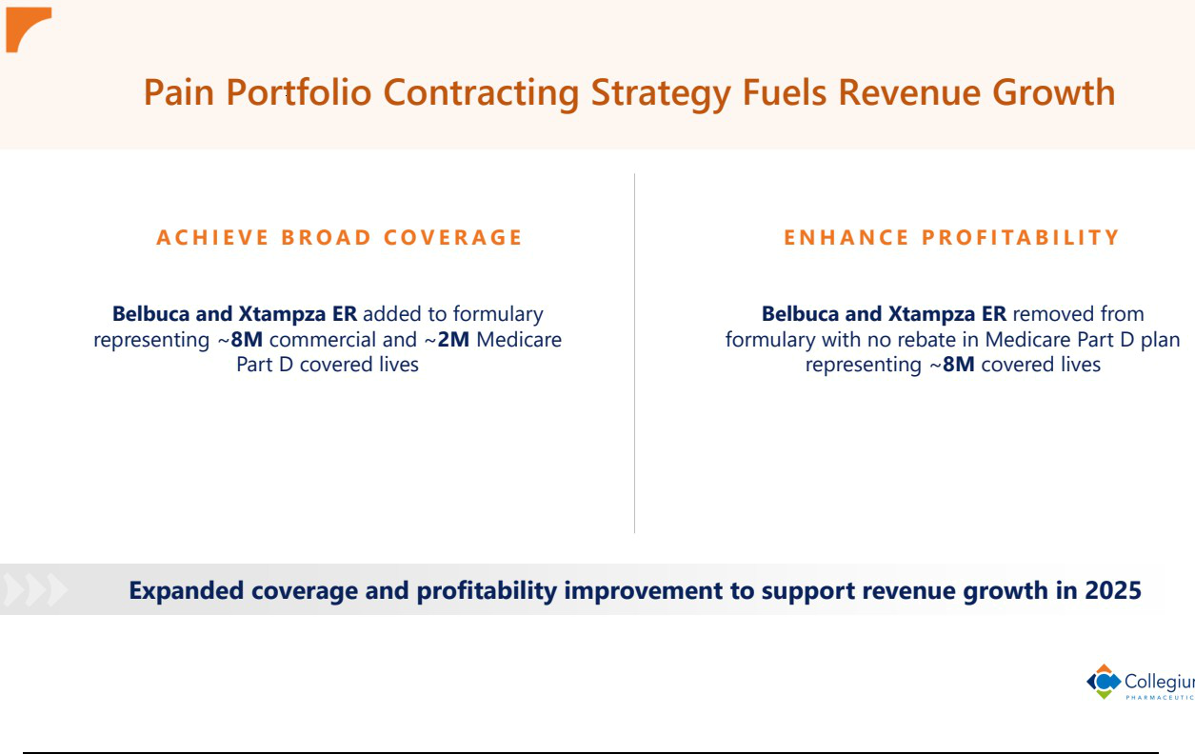



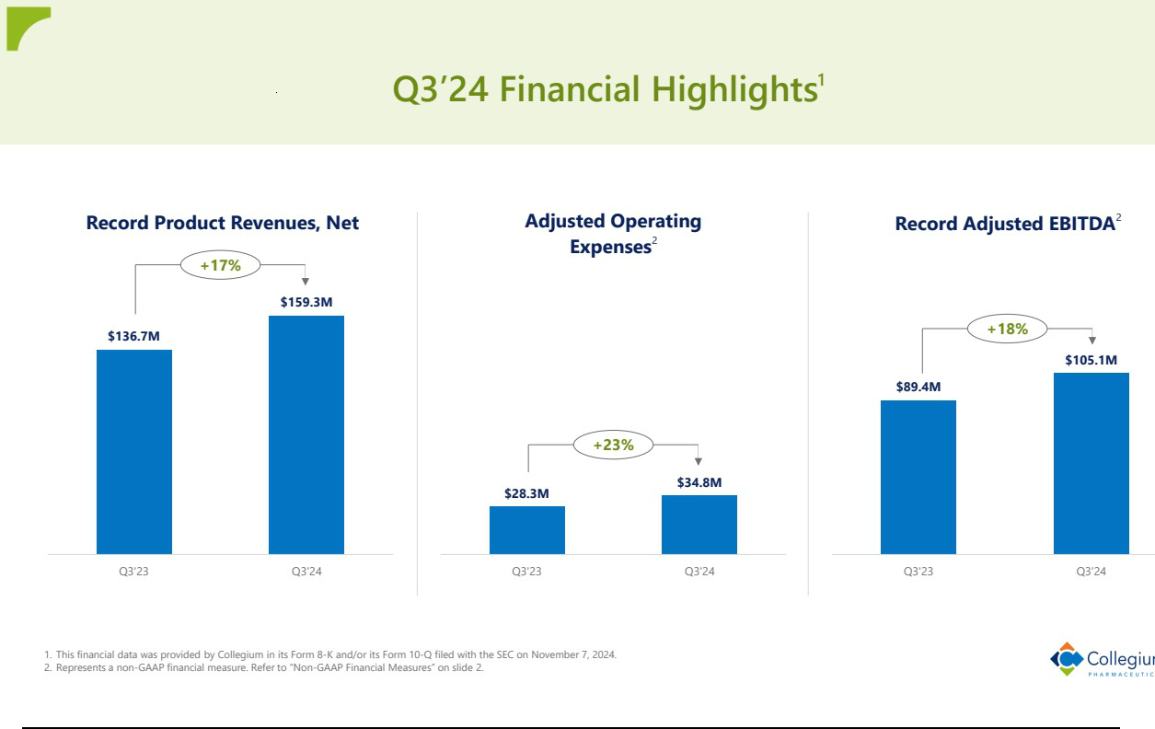

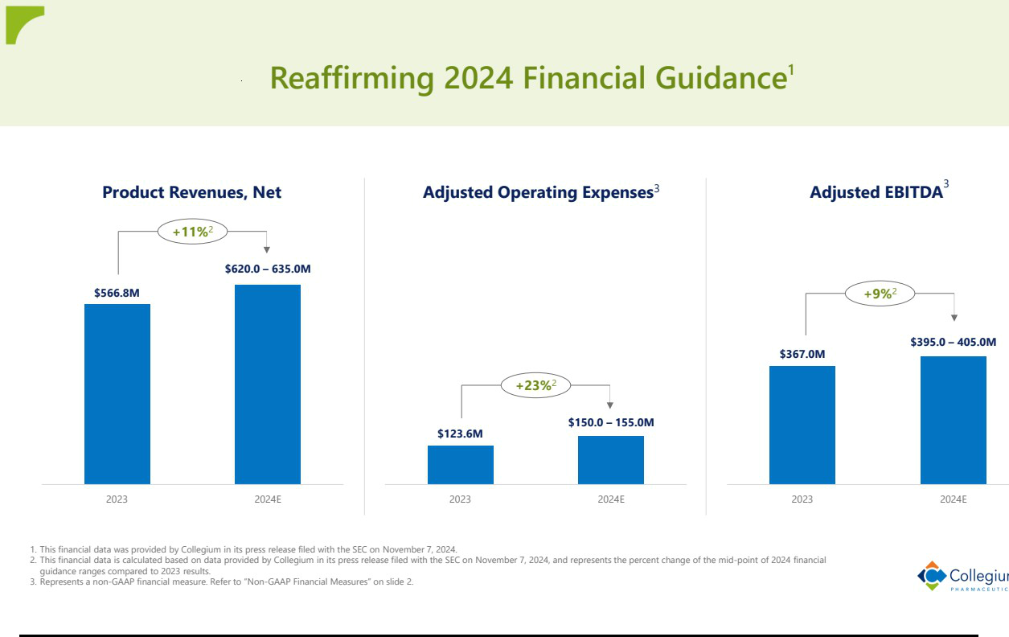

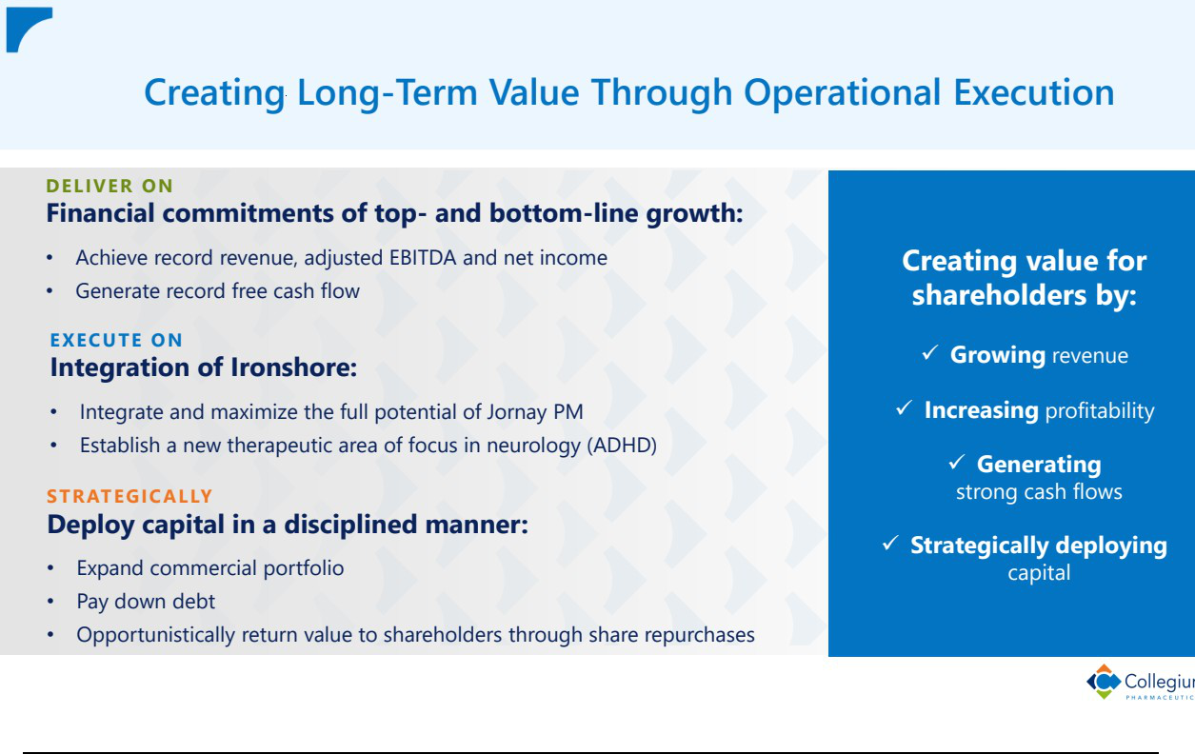

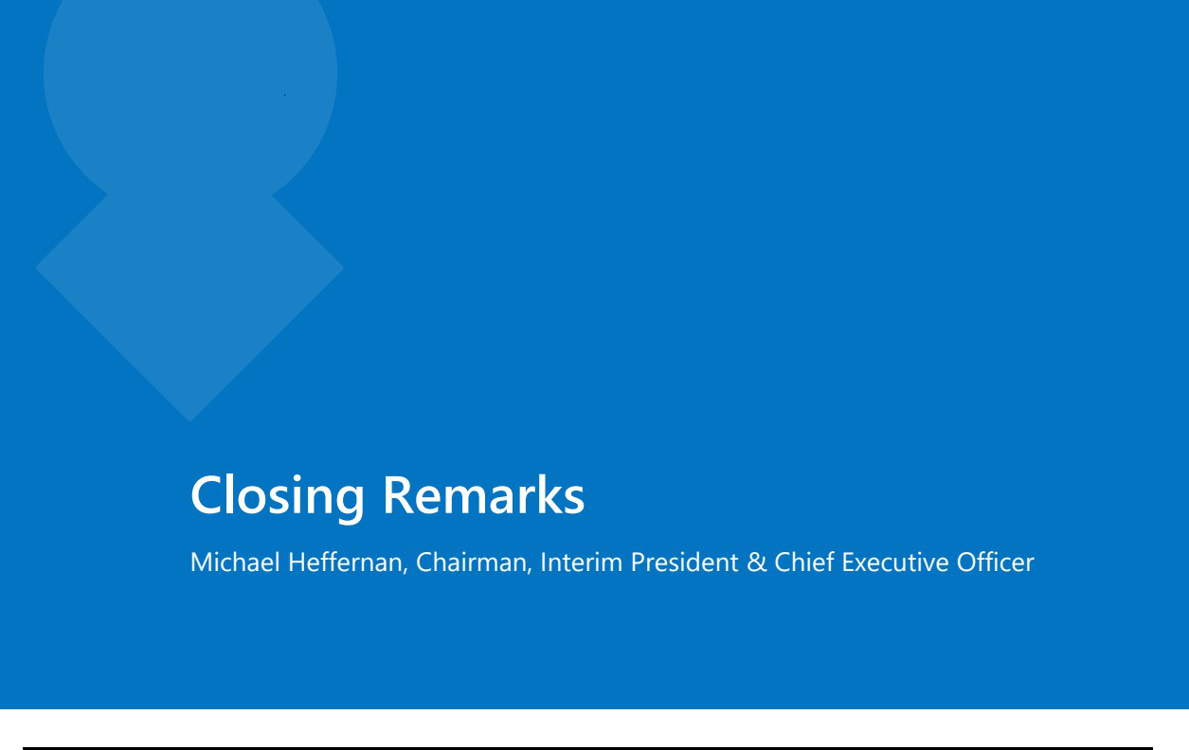





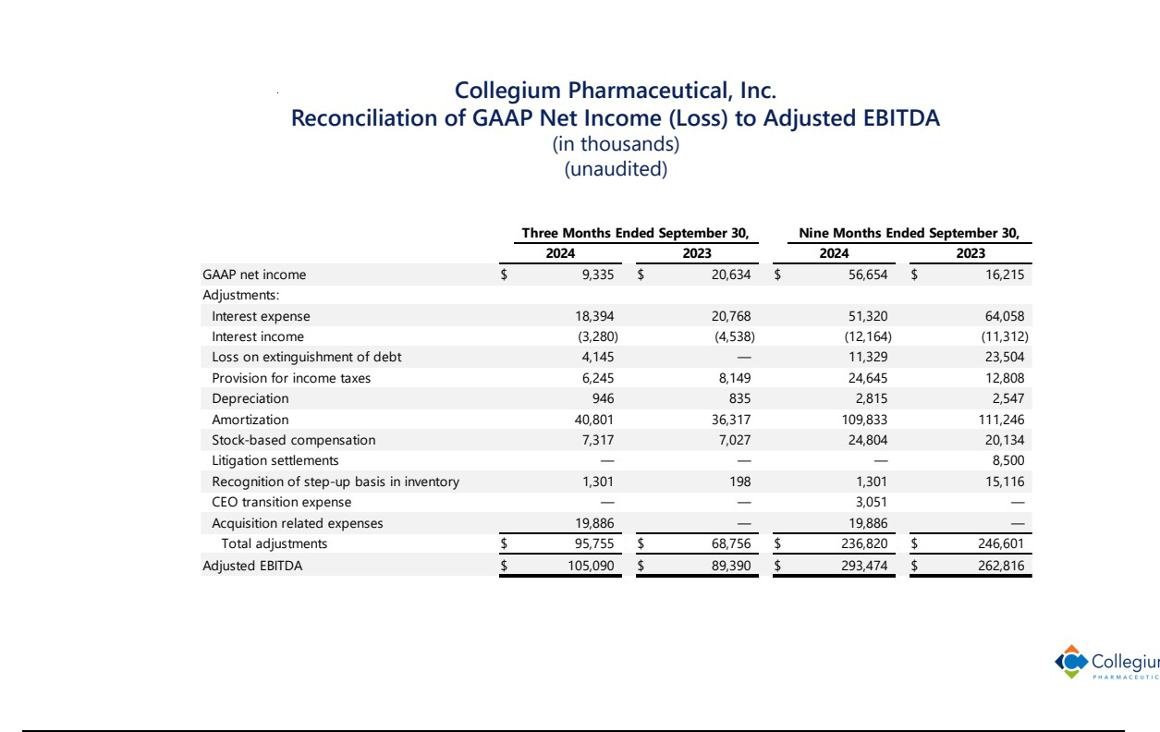

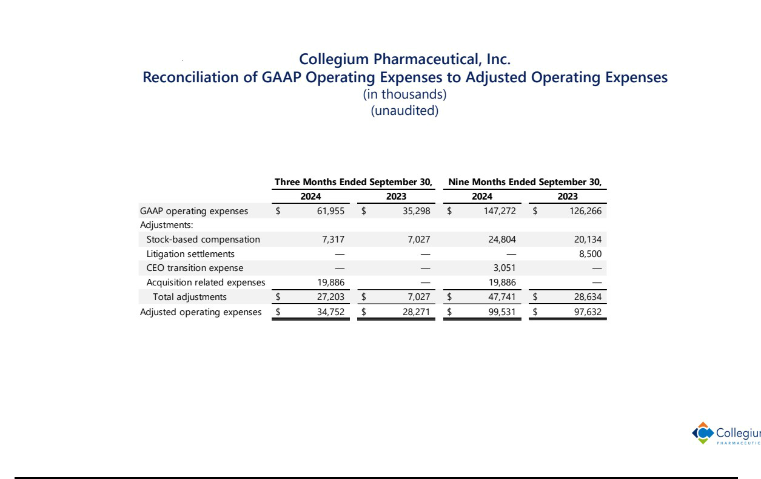

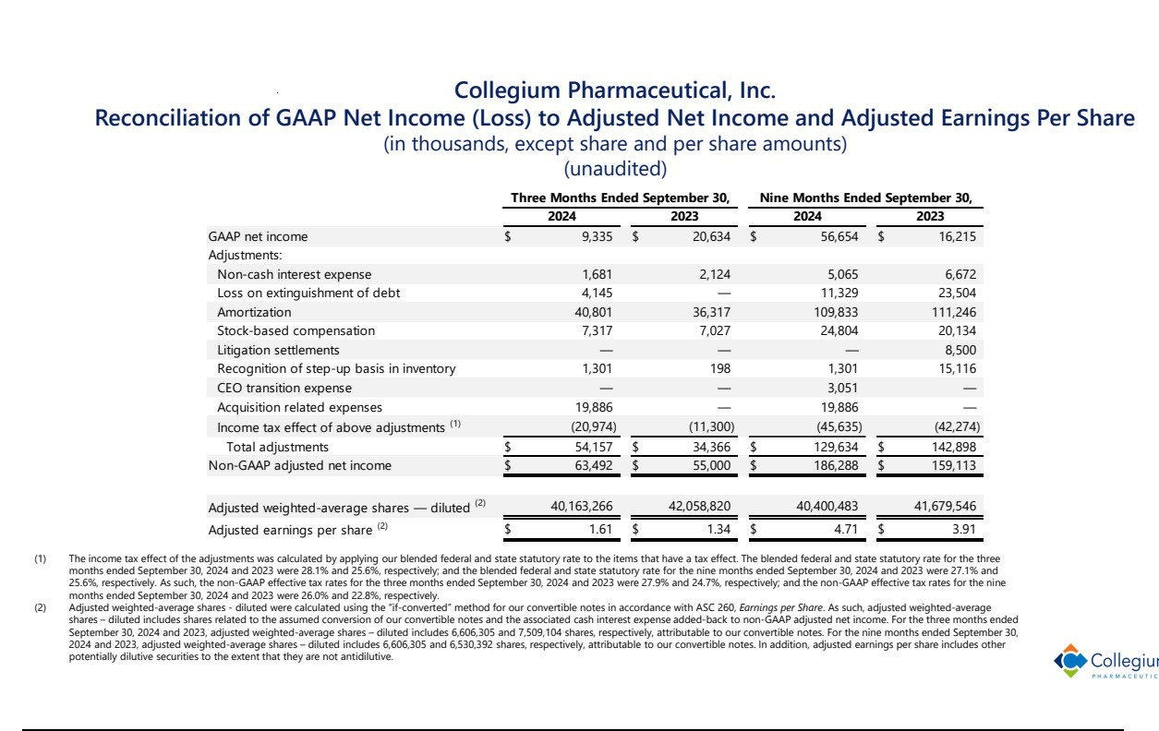

Exhibit 99.3


Collegium Appoints Vikram Karnani as Chief Executive Officer

– Vikram Karnani is a Proven Industry Leader with Extensive Experience Growing Commercial Biopharmaceutical Businesses –

STOUGHTON, Mass., November 7, 2024 -- Collegium Pharmaceutical, Inc. (Nasdaq: COLL), a leading, diversified specialty pharmaceutical company committed to improving the lives of people living with serious medical conditions, today announced that Vikram Karnani has been appointed as President and Chief Executive Officer (CEO) of Collegium and will join its Board of Directors effective November 12, 2024. Michael Heffernan, who has served as Interim President and CEO since May 2024, will remain Chairman of the Board.

Mr. Karnani has more than 15 years of leadership experience in the life sciences industry. Over the course of nearly a decade at Horizon Therapeutics, Mr. Karnani held leadership positions spanning many aspects of the business, including leading Horizon’s growth strategy and its transformation into a leader in rare disease medicines as well as establishing and expanding Horizon’s presence in international markets. This culminated in his leadership of the integration of the Horizon rare disease business into Amgen following the acquisition in 2023. During his tenure, annual net product sales grew from approximately $300 million to nearly $4 billion.

“Vikram’s demonstrated success in building organizations and maximizing their potential through both organic growth and business development makes him the right fit to lead Collegium through its next phase of growth,” said Mr. Heffernan. “The outlook for Collegium has never been stronger. With our pain portfolio delivering record revenue and Jornay PM® poised to become our lead growth driver, we are well positioned, with Vikram as our new CEO, for continued success in 2025 and beyond.”

“Collegium is a leader in specialty pharmaceuticals with an impressive track record of commercial growth and capital deployment and has a talented team dedicated to improving the lives of people living with serious medical conditions,” said Mr. Karnani. “Collegium’s leadership in responsible pain management and recent expansion into neurology underscore the Company’s significant growth prospects and ability to generate value for shareholders. I am excited to join Collegium at this pivotal time and work with this accomplished team to lead the business as we build a leading, diversified specialty pharmaceutical company.”

Vikram Karnani most recently served as Executive Vice President and President, Global Commercial Operations and Medical Affairs (Rare Disease) at Amgen, where he was responsible for driving the global commercial strategy for Amgen’s portfolio of rare disease medicines. Prior to joining Amgen through its 2023 acquisition of Horizon, Mr. Karnani held numerous roles of increasing responsibility at Horizon that culminated in his position as Executive Vice President and President of Global Commercial and Medical Affairs, responsible for Horizon’s portfolio of rare disease medicines. Before joining Horizon in 2014, Mr. Karnani served as Vice President of the Therapeutics and Cell Therapy business and held leadership roles in strategy and business development at Fresenius Kabi. Mr. Karnani has a Master of Business Administration from Kellogg School of Management at Northwestern University, a Master of Science in Electrical Engineering from Case Western Reserve University and a Bachelor’s degree in Electrical Engineering from University of Mumbai in India.

About Collegium Pharmaceutical, Inc.

Collegium is a leading, diversified specialty pharmaceutical company committed to improving the lives of people living with serious medical conditions. Collegium’s headquarters are located in Stoughton, Massachusetts. For more information, please visit the Company’s website at www.collegiumpharma.com.

Forward-Looking Statements

This press release contains forward-looking statements within the meaning of The Private Securities Litigation Reform Act of 1995. We may, in some cases, use terms such as "predicts," "forecasts," "believes," "potential," "proposed," "continue," "estimates," "anticipates," "expects," "plans," "intends," "may," "could," "might," "should" or other words that convey uncertainty of future events or outcomes to identify these forward-looking statements. Examples of forward-looking statements contained in this press release include, among others, statements related to our aspirations for the performance of our newly appointed executive and expectations relating to our future financial performance and growth.

Such statements are subject to numerous important factors, risks and uncertainties that may cause actual events or results, performance, or achievements to differ materially from the company's current expectations, including risks relating to, among others: unknown liabilities; risks related to future opportunities and plans for our products, including uncertainty of the expected financial performance of such products; our ability to commercialize and grow sales of our products; our ability to successfully integrate the operations of Ironshore into our organization, and realize the anticipated benefits associated with the acquisition; our ability to manage our relationships with licensors; the success of competing products that are or become available; our ability to maintain regulatory approval of our products, and any related restrictions, limitations, and/or warnings in the label of our products; the size of the markets for our products, and our ability to service those markets; our ability to obtain reimbursement and third-party payor contracts for our products; the rate and degree of market acceptance of our products; the costs of commercialization activities, including marketing, sales and distribution; changing market conditions for our products; the outcome of any patent infringement or other litigation that may be brought by or against us; the outcome of any governmental investigation related to our business; our ability to secure adequate supplies of active pharmaceutical ingredient for each of our products and manufacture adequate supplies of commercially saleable inventory; our ability to obtain funding for our operations and business development; regulatory developments in the U.S.; our expectations regarding our ability to obtain and maintain sufficient intellectual property protection for our products; our ability to comply with stringent U.S. and foreign government regulation in the manufacture of pharmaceutical products, including U.S. Drug Enforcement Agency, or DEA, compliance; our customer concentration; and the accuracy of our estimates regarding expenses, revenue, capital requirements and need for additional financing. These and other risks are described under the heading "Risk Factors" in our Annual Reports on Form 10-K and Quarterly Reports on Form 10-Q and other filings with the SEC. Any forward-looking statements that we make in this press release speak only as of the date of this press release. We assume no obligation to update our forward-looking statements whether as a result of new information, future events or otherwise, after the date of this press release.

Investor Contact:

Danielle Jesse

Director, Investor Relations

ir@collegiumpharma.com

Media Contact:

Marissa Samuels

Vice President, Corporate Communications

communications@collegiumpharma.com

